

Project Proposal:

**Body Branding Bookings (3B)**

A website for managing appointments for tattooists, piercers, body modifiers and their clients.



Joey Tatú

15015556

[joey.tatu@student.ncirl.ie](mailto:joey.tatu@student.ncirl.ie)

BSc (Hons) in Computing – Software Development

National College of Ireland

October 2019

Contents

Annotations 2

1. Objectives 2

General 2

Databases 2

Reviews 2

Appointments 2

Artificial Intelligence 2

2. Background 2

3. Technical Approach 4

Pages, profiles and bookings 5

Messaging service 5

Payments 5

Automated appointments and stock control 5

Version control and methodologies 5

4. Special resources required 5

5. Research 6

Personalisation 6

Optimisation 6

6. Project Plan 7

7. Technical Details 7

8. Evaluation 7

Unit Testing 7

Scenario 1: Create and manage Page/Profile: 7

Scenario 2: Messaging Service 8

Integration Testing 9

Scenario 1: Client creating a review. 9

Scenario 2: Artist’s working availability 9

Scenario 3: Client booking an appointment 9

Scenario 4: Messaging 9

Scenario 5: AI: Appointments 10

Scenario 6: AI: Stock control 10

Performance Testing 11

References 12

# Annotations

|  |  |
| --- | --- |
| 3B | Body Branding Bookings |
| Artist | Tattooist, piercer or body modifier |
| Client | Customer of the artist |
| User | Artist and/or a client |

# Objectives

## General

The object of this Project is to take a brick and mortar scenario[1] of where artists and clients process appointments and payments manually, and create a website where this can be automated.

There will be two main types of accounts on the website; artists and clients. The artist account can either be a solo artist or a collection of artists.

## Databases

There will be two databases connected to the website. One database will be for the artist pages, client profiles and the actual appointments. The other database will be for the stock and the stock control.

## Reviews

Reviews of the artists will be generated by the clients. These will be visible on the Artist’s page on the website. The Artist can choose to hide a review. Clients must have at least one previous booking with a particular Artist to review that artist. This will avoid people never visiting the Artist or artist posting reviews.

## Appointments

Artists will generate what days and times the artist(s) are working. The client will book an appointment that is free with the artist. Sample sizes will be provided to generate the correct amount of time to be reserved. A deposit or full payment will be required from the client to confirm their booking.

## Artificial Intelligence

Artificial Intelligence will focus of individualisation as well as the issue of optimisation.

With individualisation, the client will have recommendations. For example, if they generate a piercing appointment, the likes of piercing jewellery or piercing locations would be recommended to them.

With the issue of optimisation, the likes of security and payment handling will be discussed and implemented.

# Background

The original idea for this project came about in early 2019. The thought process was to create a social networking Android app. A website, Inked-Up.com, was a comparison for the app. This site specifically targets adult men who are into body modification such as tattoos and piercings. With this site, it’s felt that it is dealing with a very distinctive niche which would not be ideal for everyone. The site also seems very outdated and seemingly has become a replacement platform from Tumblr, since adult content is no longer permitted. (Tatú, 2018) (Inked-Up.com, 2019)

With new social networking platforms being developed, with an example of TikTok being the newest and most popular, the app was going to be similar to the likes of Facebook and Inked-Up.com, but for everyone with an interest in body modifications. The ability to rate tattoo Artists was also to be implemented.

With this current project, it will be on the same general topic; tattoos, piercings and body modifications. Trying to book an appointment to get a tattoo or piercing is quite tedious in some situations. Contacting the artist or Artist can be troublesome, either contacting them through social networking sites or by email. There are delays in communication. It seems like a long process just to get an appointment.

It’s common knowledge that, especially, for getting a tattoo, a deposit is required. This means that the client needs to go to the Artist or tattooist, give their deposit, and then return for the appointment. If the client doesn’t pay the deposit, their appointment is still there and it wastes the artist’s time. A good starting point to this project is to automate these.

To remedy this, the idea of Body Branding Bookings (3B) was generated. With 3B, the artist can select the dates they wish to work and where they are available. The clients can book one of these timeslots. The general size and/or the time it will take to complete the appointment will be set by the artist and selected by the client to determine the correct time slot needed to be allocated. Artists will have a page where clients can rate and leave reviews.

Java, JavaScript and jQuery will be revisited. These will greatly be beneficial to the project. If a new language is needed, it will be heavily considered.

# Technical Approach

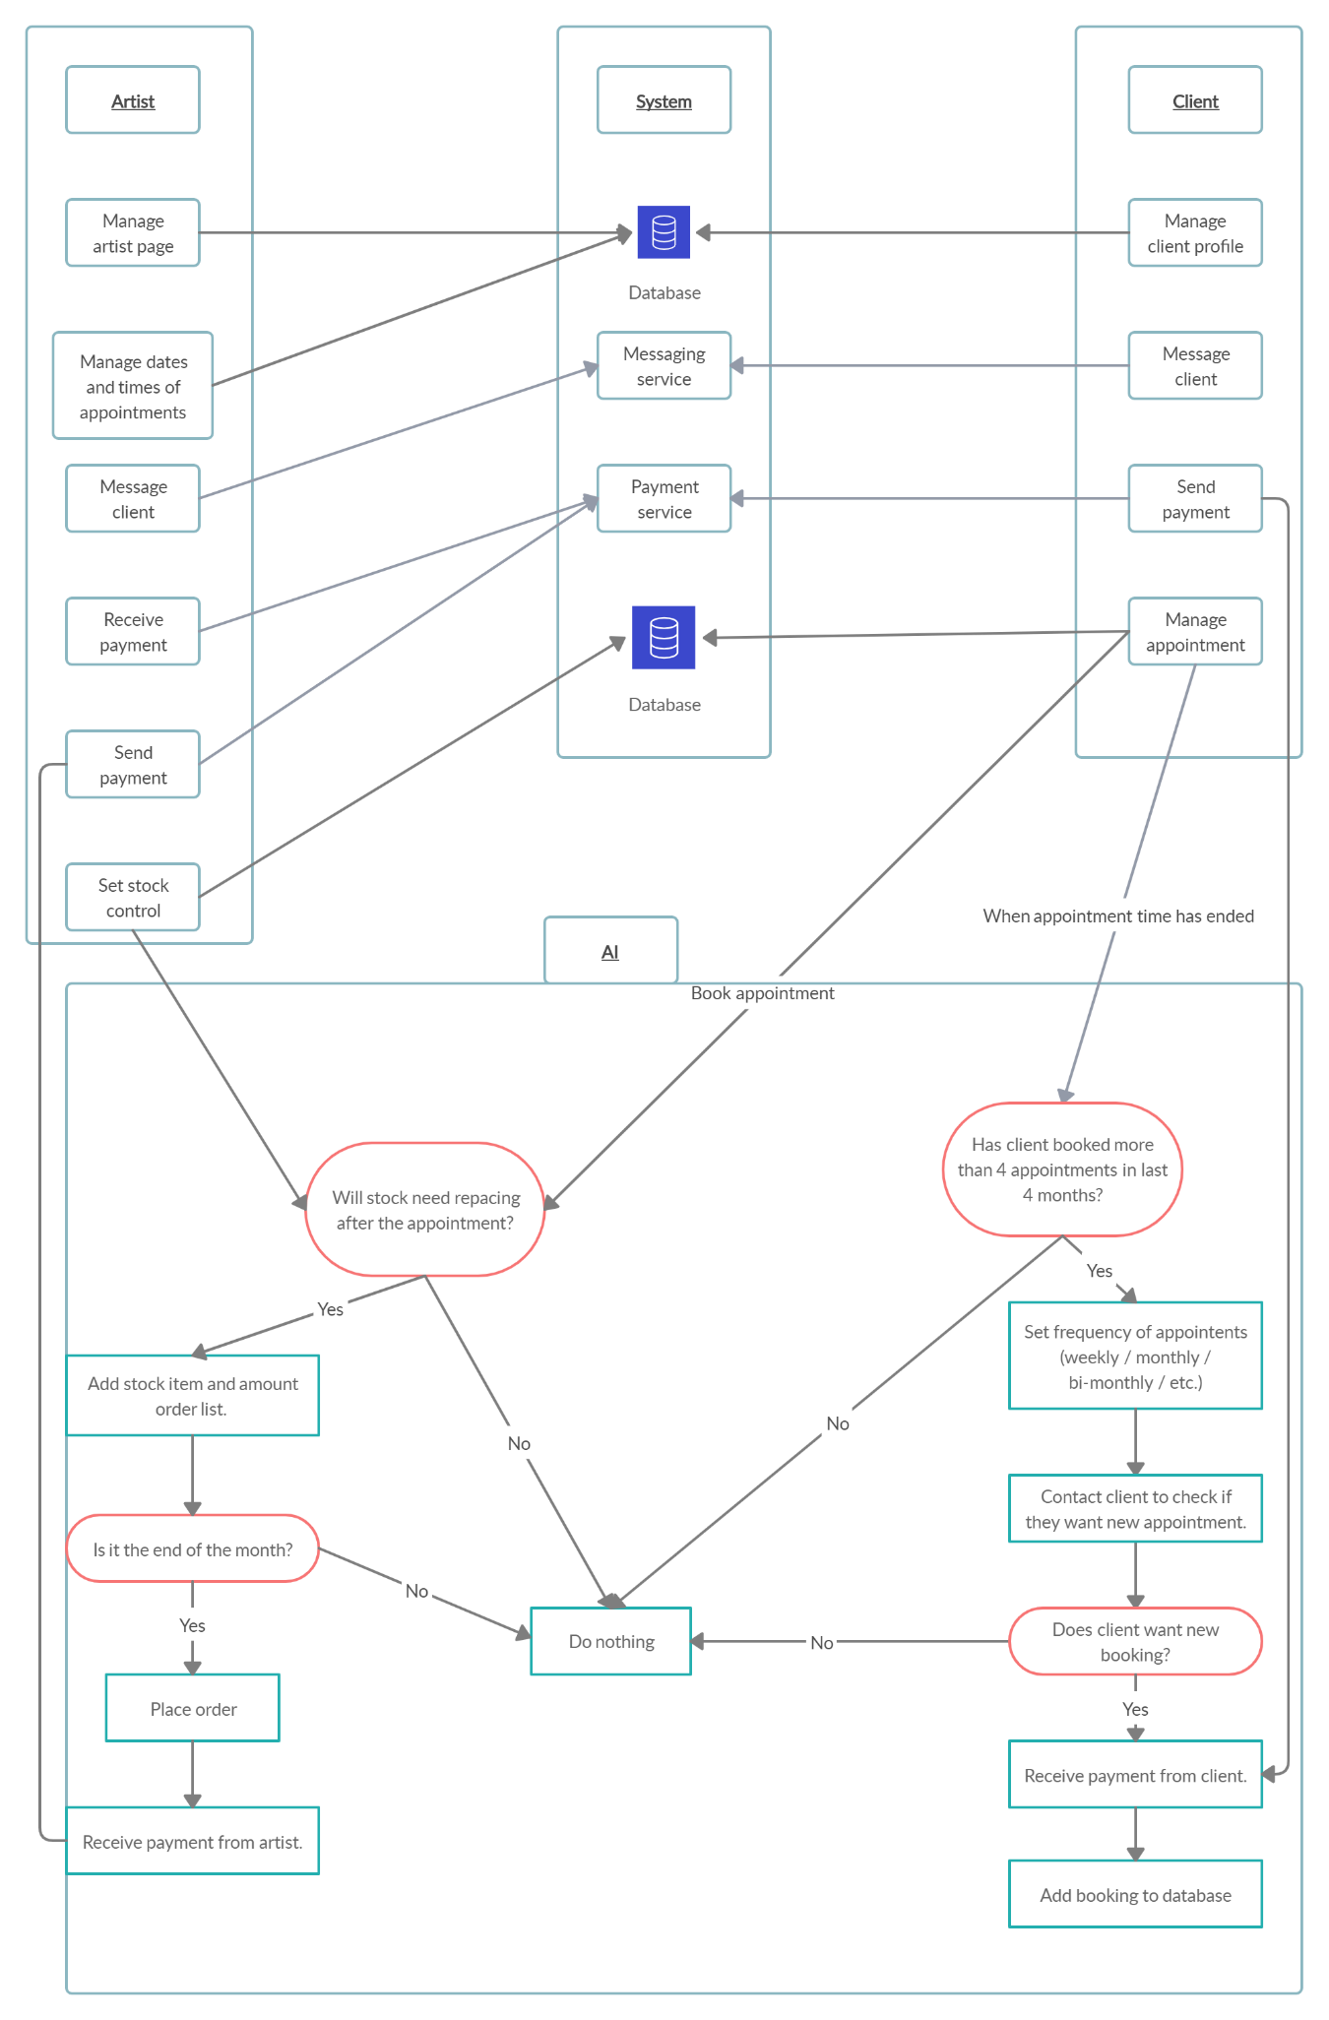

(External image attached, see “TechApproach.png”)

These are the foundations for the project;

## Pages, profiles and bookings

Artist pages and client profiles are essentially the same thing, but with different fields and privacy settings. Pages are for finding, rating and leaving a review for the artist, where as the client profiles will be private and not have these features. The client decides what information is public to a particular artist when booking an appointment.

Artists will be inserting the dates and times they are available to work and the client will be selecting a time slot that the artist has defined. These will be implanted using standard website coding, such as HTML, CSS and JavaScript and will be put into a secure database using SQLite.

## Messaging service

The messaging service will be created using (the coding language) Earling. However, if this becomes unfeasible, a messaging service like SendBird will be used instead. It seemingly has the most simplified API to use for this Project.

## Payments

All payments will be handled using an online service. The ideal solution would be to use PayPal and their API, but Visa and Mastercard’s API will also be considered.

## Automated appointments and stock control

This is where AI plays a role for this project. The idea is that if a client books 4 or more appointments in a 4-month period, the AI will contact the client and ask them if they wish to book an appointment that would fall on a date and time similar to their previous appointments.

With stock control, the artist will input their stock and how much is used for each appointment, such as piercing needles, tattoo ink, gloves, alcoholic wipes, and so on. When a client books an appointment, that stock is set to be removed from the inventory when the appointment is complete. The AI will monitor the stock amounts, and will add it to an order list when it reaches below a certain number, which is set by the artist.

These will be implemented using Java and Java Standard Pages (JSP).

## Version control and methodologies

To deal with version control, GitHub and Git Bash will be used. (<https://github.com/JoeyTatu/SoftwareProject>)

For the methodologies, a mix of Scrum and Kanban will be used. (Tatú, 2018)

# Special resources required

It is expected that the project will be completed using online tools and services, where possible. This project is expected to be available using Amazon Web Services or similar. (Tatú, 2018)

# Research

## Personalisation

Brick-and-mortar stores are beginning to put more digital knowhows into their stores. For the clients, this is a great benefit for them by making their experience better. Some of the brick-and-mortar stores are not developing their business’ technological skills, in regard to customer interaction. (Betzing, et al., 2018) However, there are methods of doing this.

When developing from a brick-and-mortar store to a more digitised one, the likes of sensors such as cameras and facial recognition devices can figure out the basics of a person; such as their height, gender, and approximate age. A person’s facial expressions can also be considered to explore whether the client is in a positive or negative mood and whether they are enjoying the service. This data can be obtained by using smart devices on a local network. (Betzing, et al., 2018) (Webner, 2019)

This concept is similar to the physical store Amazon Go by Amazon, where Artificial Intelligence is used to keep track of the clients and store items. (McFarland, 2018)

In this project, it is hoped that a personal experience can be added for the artists and clients. It is expected that personalisation with be sought from a user’s profile, such as their age, gender.

In an example of how this could work; a male client who has just turned 18 and would like to get a tattoo. The system would ask the client to heavily consider whether they would want the tattoo, and to seriously consider avoiding visible areas such as the face, head or hands.

However, if the client is a male in their mid-40s, this message would not be shown to them as the thought process for the client would be different. It could be assumed the client already has a lot of tattoos. Instead, an upload link to share their previously obtained tattoos would be shown. This is developed further in the Requirement Specifications.

## Optimisation

Another consideration of this project is optimisation. If one takes the clothing and textile industry as an example, one can optimise what colours, fabrics and designs are in a high demand. This is completed by eliciting and gathering “Product Usage Information (PUI)”. This is obtained from clients, experts and investors. From this data, the latest styles and what the client wants are known. (Hribernik, et al., 2019)

In this project, optimisation could be used for the general size of the tattoo, the colours of the ink used. If, for example, a lot of tattoos are small and use only use 3 or 4 colours, the system would recognise this and automatically order new colour inks to the artist. On that note, the artist could input how much ink would be used for a particular size and machine learning could be used to order and maintain stock with the artist.

The same would also go for piercings, if a certain ring or stud is used on a regular basis, these could be automatically ordered. The likes of stock control for piercers could also be controlled here. This will be developed with the Requirement Specifications.

# Project Plan

This is the Project Plan. It currently shows all the major milestones and will be updated throughout the Project. (Tatú, 2018)

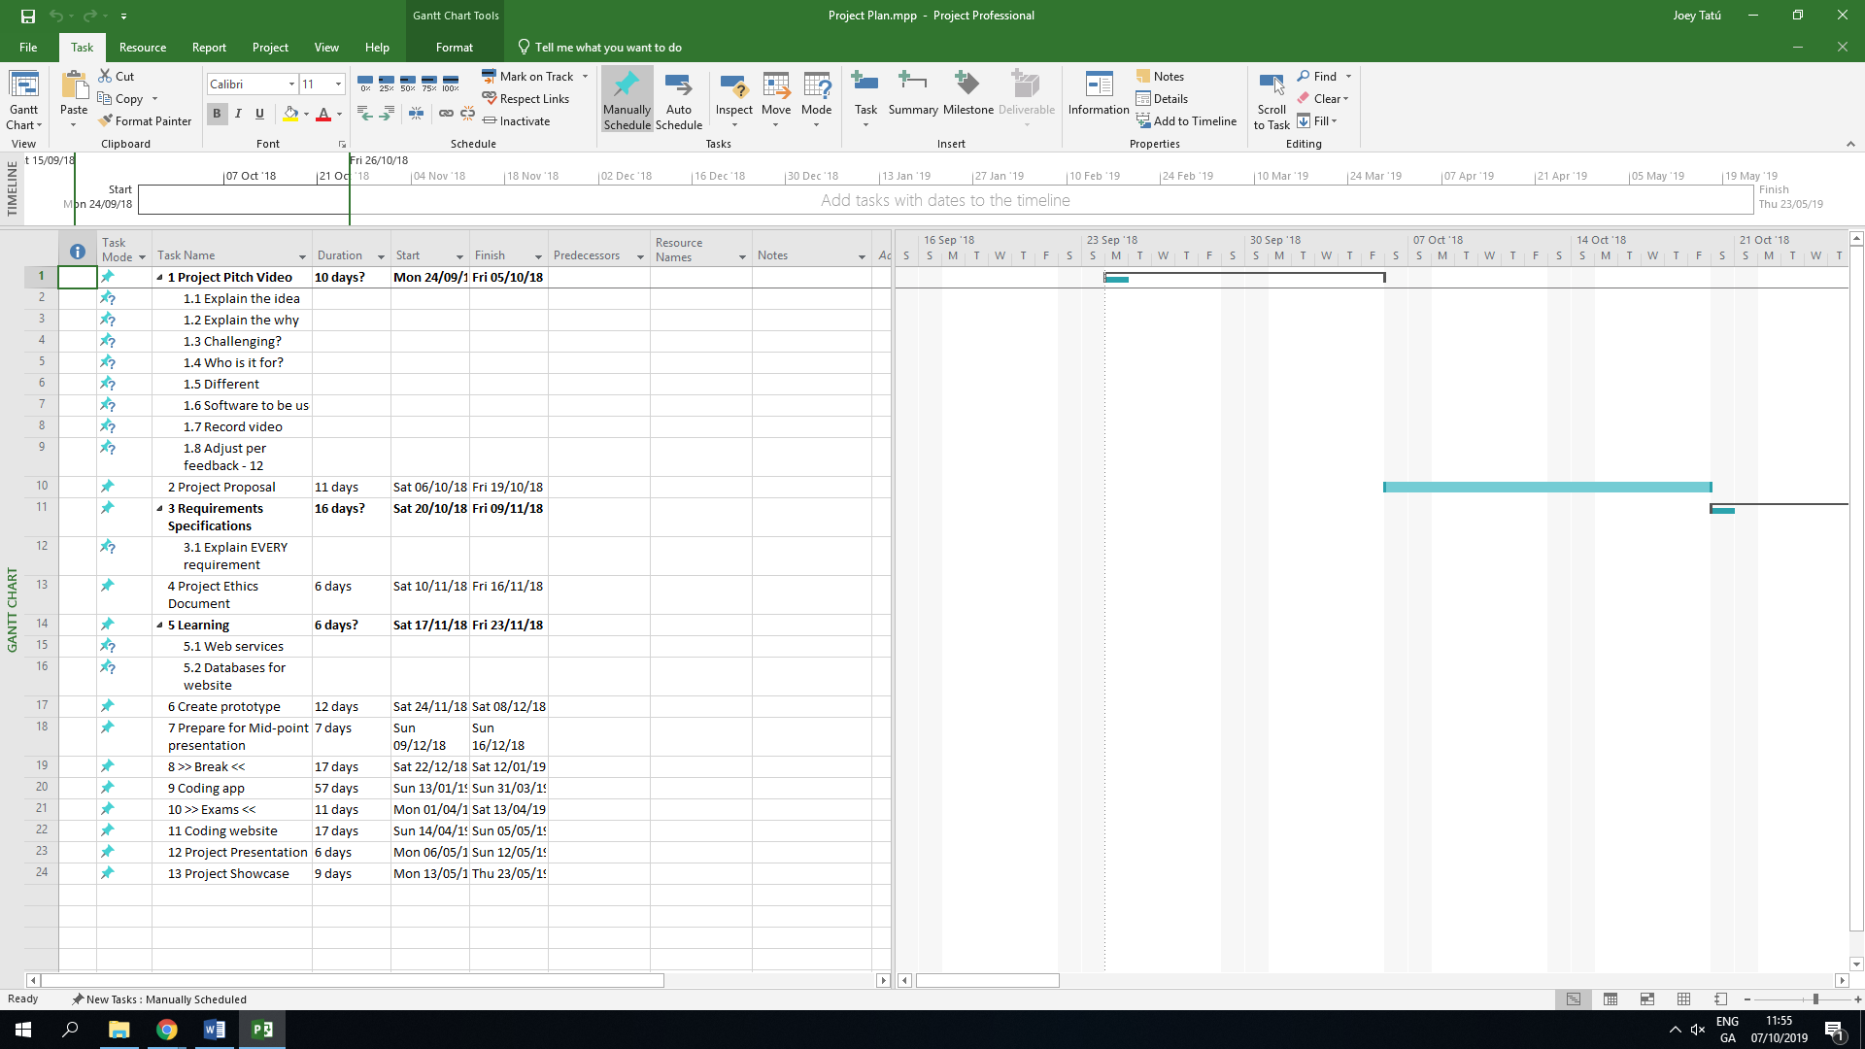

# Technical Details

Web-coding languages such as HTML, CSS, XML, JavaScript (etc) will be used along with SQL (more than likely SQLite). It is expected that Java will be used for the Artificial Intelligence part, but other languages will be considered. (Tatú, 2018)

# Evaluation

All results will be added to the Testing Report to identify and fix errors.

## Unit Testing

An artist page and client profile has been previously created.

### Scenario 1: Create and manage Page/Profile:

* Are the permissions set correctly for either the artist or client?
  + Permission settings will be set so that the artist cannot see the client’s profiles.
  + Permission settings will be set so that clients may not see other client’s profiles.
  + If these are successful, this test passes.
* Is the data securely sent to and retrieved from the database?
  + An example date and time appointment will be created.
  + Before sending to the database; an interjection program will be used to view the data being sent to the database.
  + If the data van be viewed by using this interjection method, this test is a fail.
  + To succeed, the data should not be viewable to anyone other than the database.
* Can a client correctly add ratings and reviews to artist page?
  + The client adds a rating to the artist’s page.
  + The client adds a comment to the artist’s page.
  + If there are no error, this test passes.

(This method does not send data. It just tests whether this is doable)

### Scenario 2: Messaging Service

* Can a client start a conversation with an artist?
  + Permissions will be set so a client can message any artist.
  + It is expected that HTML forms and JavaScript will be used for this.
  + Sent and received messaged will be displayed as their sent or received.
  + A client writes a sample message
  + If the message is successfully sent, this test passes.

(This method does not send data. It just tests whether the message is submitted.)

* Can an artist start a conversation with a client, only after they book an appointment?
  + Permissions will be set so a artist can reply to messages new clients send to them or who have booked an appointment with them.
  + It is expected that HTML forms and JavaScript will be used for this.
  + Sent and received messaged will be displayed as their sent or received.
  + Artist writes a sample message to the permissible client.
  + If the message is successfully sent, this test passes.
  + Artist writes message to a new client, who does not have an appointment with them or the client has not messaged them previously.
  + If the message sends, the test fails.

(This method does not send data. It just tests whether the message is submitted)

## Integration Testing

The artist page and client profile have previously been created.

### Scenario 1: Client creating a review.

* Integration between the artist’s pages/customer profiles and the database.
  + The client account rates the artist page.
  + The client puts an example comment on the artist page.
  + The reviews and comments are sent securely to the database as arrays.
  + The page is reloaded using JavaScript.
  + The comments and reviews are pulled from the database and shown correctly.
  + The test has passed.

### Scenario 2: Artist’s working availability

* Integration between the appointments and the database.
  + The artist selects the dates and times they are available to work
  + The artist submits these to the database
  + The dates and times are stored in the database.
  + The page is reloaded using JavaScript.
  + The highlighted dates and times are pulled from the database and shown correctly.
  + The test has passed.

### Scenario 3: Client booking an appointment

* Integration between the appointments and the database.
  + The client selects the date, start time, type (tattoo/piercing) size and general area.
  + The client submits these to the database
  + The details are stored in the database
  + The payment is handled by PayPal API.
  + Payment is set to “Confirmed” on receipt of PayPal API
  + The page is reloaded using JavaScript.
  + The highlighted dates and times are pulled from the database and shown correctly to the client.
  + The database updates the artist’s availability and selects the client’s appointment as “booked” in the appropriate date and time fields.
  + The test has passed

### Scenario 4: Messaging

* Integration between the message server and the artists/clients.
* Client messages artist.
  + Permissions will be set so a client can message any artist.
  + Sent and received messaged will be displayed as their sent or received.
  + A client writes a sample message.
  + The message is sent to the message server
  + The message server displays the message in the artist’s messages.
  + If the message is successfully displayed on the artist’s messages, this test passes.
* Artist messages client
  + Permissions will be set so a artist can reply to messages new clients send to them or who have booked an appointment with them.
  + Sent and received messaged will be displayed as their sent or received.
  + The message is sent to the message server
  + The message server displays the message in the client’s messages.
  + If the message is successfully displayed on the client’s messages, this test passes.
  + Artist writes message to a new client, who does not have an appointment with them or the client has not messaged them previously.
  + The message is sent to the message server
  + The message server displays the message in the client’s messages.
  + If the message is successfully displayed on the client’s messages, this test fails.

### Scenario 5: AI: Appointments

* The AI code will be created using Java and Java Server Pages (JSP)
* Integration between AI and booking appointments.
  + For testing purposes, the amount of appointments that the client has booked in the past 4 months is set to 5.
  + The AI looks at the time between the appointments
  + The AI calculates when the next appointment will be on average.
  + The AI pre-books the appointment.
  + The AI emails the client for confirmation

(The email contains a link for the client to pay a deposit)

* + When confirmation is retrieved, the AI changes the booking to confirmed.
  + The AI sets the appointment in the artist’s working availability.
  + If these are completed, the test has passed.

### Scenario 6: AI: Stock control

* The AI code will be created using Java and Java Server Pages (JSP)
* Integration between AI and stock control.
  + Items with a range of amounts and prices will be added.
  + Daily, the AI searches the stock and keeps track of what stock items has a quantity of 25 or less.
  + The AI checks the status of these items. If “not-ordered” is a status it adds these items to the order list.
  + If the items have an “ordered” status, these items are ignored.
  + Manually, the system time will be set to the last day of the month at 17:58h.

(Last day of the month at 18:00h is set for the order form to be emailed to the supplier)

* + At 18:00h, the AI adds the items to the order form using a template
  + The AI adds the quantity of 100 to each item.
  + If the AI emails the supplier correctly, the test has passed.

## Performance Testing

Performance Testing will be completed using JUnit.

The following are what will be tested:

* Response time:
  + Check that the response time is less than 4 seconds with a user base of 500.
  + Check the response time of the website when a user’s connection is slow or limited.
  + Check response time when the load condition is low, medium and heavy.
* Users and database
  + Check the maximum number of users the website can handle before it crashes.
  + With 500 records are sent/received to the database, check the execution time. The limit would be 10 seconds.

# References

Betzing, J. H., Hoang, A.-Q. M. & Becker, J., 2018. *In-store Technologies in the Retail Servicescape,* Münster: University of Muenster.

Hribernik, K., Arabsolgar, D., Canepa, A. & Thoben, K.-D., 2019. Applying Product Usage Information to Optimise the Product Lifecycle in the Clothing and Textiles Industry. In: *Product Lifecycle Management (Volume 4): The Case Studies.* Basel: Spinger, Cham, pp. 73-95.

Inked-Up.com, 2019. *Inked-Up.com.* [Online]   
Available at: http://inked-up.com  
[Accessed 18 October 2019].

McFarland, M., 2018. *I spent 53 minutes in Amazon Go and saw the future of retail.* [Online]   
Available at: https://edition.cnn.com/2018/10/03/tech/amazon-go/index.html  
[Accessed 16 October 2019].

Tatú, J., 2018. *Social Modifications,* Dublin: National College of Ireland.

Webner, F., 2019. Streaming Analytics—Real-Time Customer Satisfaction in Brick-and-Mortar Retailing. In: *Cybernetics and Automation Control Theory Methods in Intelligent Algorithms.* Essen: Springer, pp. 50-59.

1. A **brick-and-mortar store** is a traditional store that you find (e.g.) in your local shopping centre.